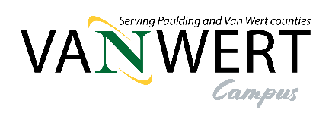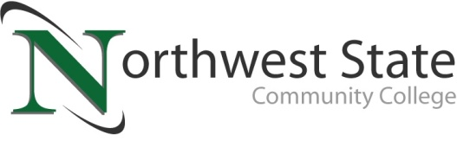

**DATE:** March 17, 2025

**CONTACT:** Jim Bellamy 419.267.1267 jbellamy@NorthwestState.edu

**NORTHWEST STATE VAN WERT CAMPUS ANNOUNCES FALL 2025 COURSES**

*ARCHBOLD, OHIO –* Your Van Wert Campus of Northwest State Community College is excited to announce the opening of registration for our Fall 2025 semester. And, most exciting of all, the Van Wert Campus will be open and fully operational for our August 20, 2025 semester start!

Our onsite class offerings allow enrollment in several career pathways:

**Associate Degrees:**

Accounting

Banking & Finance

Business Management

Entrepreneurship

Marketing

Computer Programming

Cyber Security Network Administration

Electrical Engineering

Industrial Technologies

**Short-Term Certificates:**

Accounting Assistant

Entrepreneurship

Marketing

Computer Technician

Cyber Security

Industrial Electrical

Medical Coding and Billing (online only)

Classes are available for all student groups, including traditional aged college students, non-traditional/part-time students, students looking to transfer credit back to their home university, workforce development and upskilling, and college credit plus/dual enrollment.

Additionally, your Van Wert Campus is offering our **First Course Free scholarship** to go along with the $900,000 in NSCC Foundation scholarships awarded annually and institutional scholarships that can provide up to 100% tuition.

To begin your future educational career or gather more information, please visit the Van Wert Campus website at **NorthwestState.edu/VanWert**. On our Van Wert Campus website, you have access to review all our Academic Divisions, ask any Admissions questions, review Financial Aid and scholarship information, and apply to begin your future at Northwest State Community College. The current courses offered can be found at **NorthwestState.edu/calendars**.

More information on courses and our Van Wert Campus can be directed to Dr. Jon Tomlinson by emailing **vanwert@northweststate.edu**, calling our Van Wert Campus at 419-267-1399, or visiting our current storefront at 122 N. Washington Street. If you have Enrollment questions, please email Rachel Verville at rverville@northweststate.edu.

###*##*

*Northwest State Community College is an accredited two-year, state-assisted institution of higher education that has served northwest Ohio since 1969. Northwest State is committed to providing a quality, affordable education with personal attention and small class sizes. The College offers associate degrees with numerous transfer options, short-term certificate programs, and workforce training programs designed to meet the needs of local businesses and industries. For more information, visit NorthwestState.edu or call 419.267.5511.*